**LETSUPGRADE LINUX ADMINSTRATION**

**DAY 3 ASSIGNMENT**

**Q1. Creating And Verifying** myfile **By Using touch command**

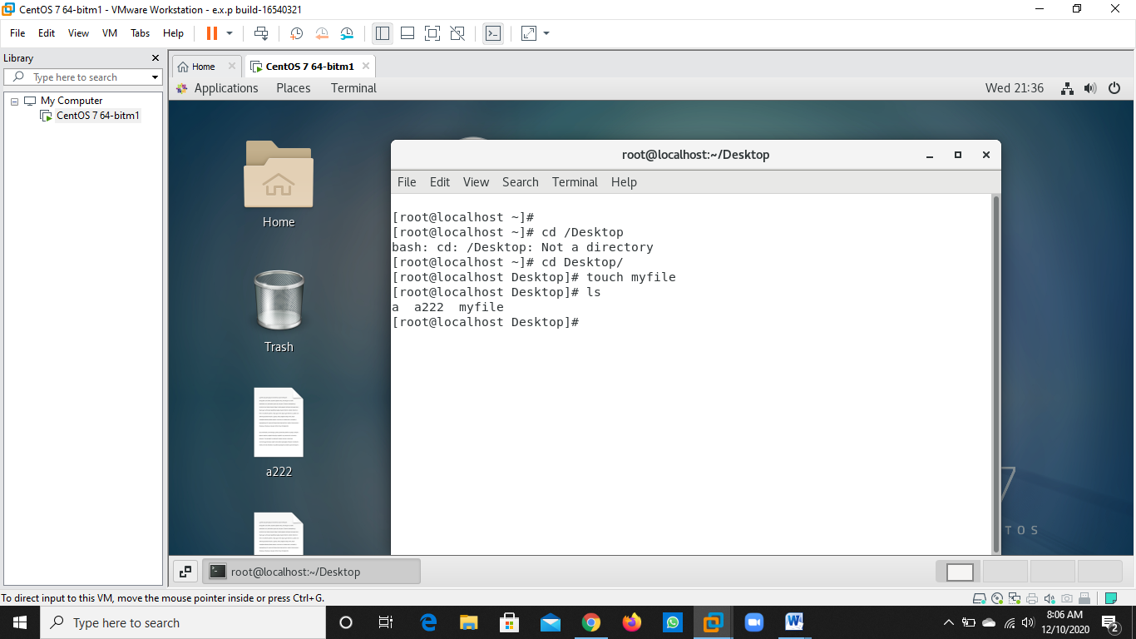

**Q2. Opening The File Using Vi Editor**

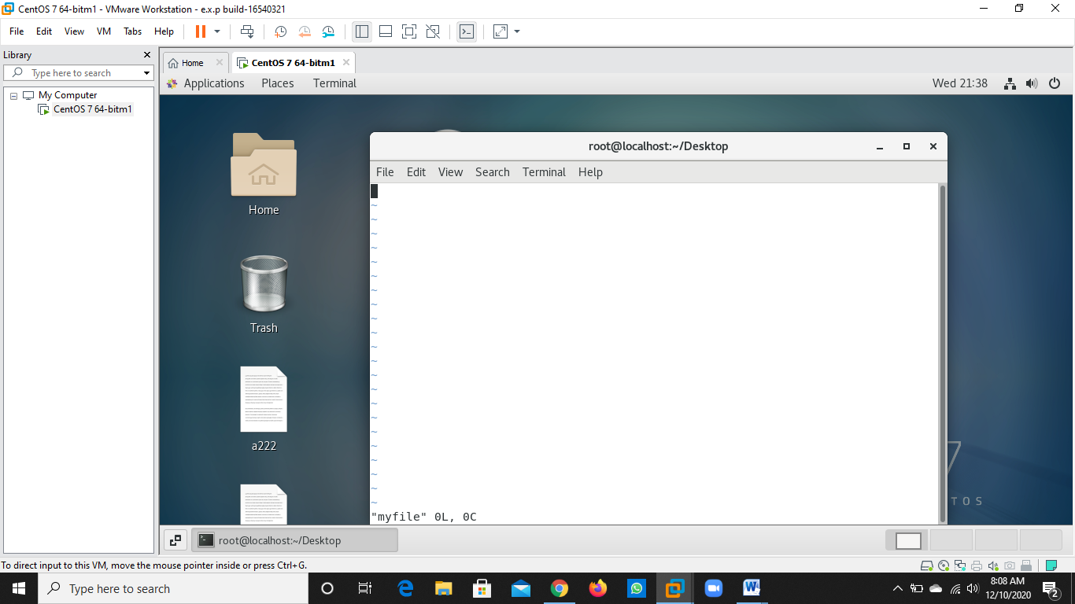

**Q3. Writing The Details And Saving It By Using :wq! Then Opening It By Using cat command**

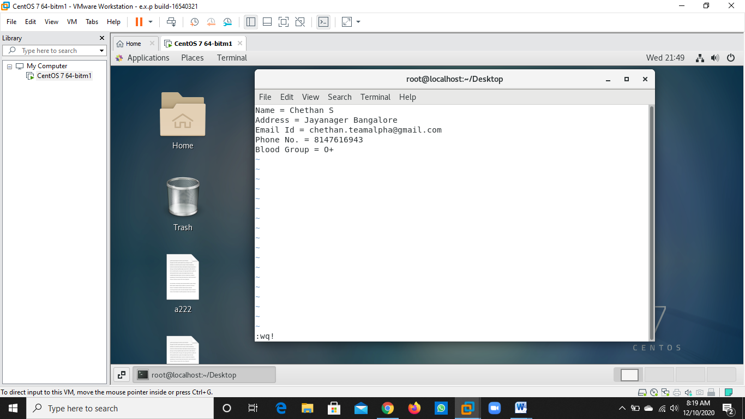

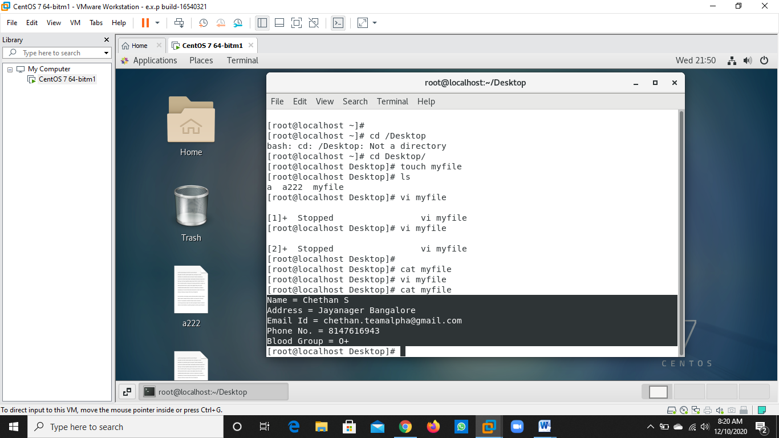

**Q4. Creating one single expression to find the name and blood group line**

